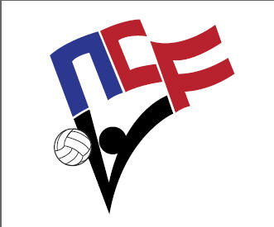
NCVF Coach of the Year Award
2022 Nomination Form

The NCVF Coach of the Year Award was developed to recognize outstanding efforts for coaching excellence in collegiate club volleyball. If you feel your coach should be considered for the award, please complete the attached nomination information, along with a brief 1-2 paragraph essay explaining the reasons why he/she should be selected. All criteria will be considered such as coaching style, team record, efforts on/off the court, outstanding coaching qualities, volunteerism, as well as others that you feel are important to consider. All nominations should be submitted to Nick Collins (ncollins@ncvf.org) no later than April 10th, 2022. A committee will review all nominations and select the outstanding candidate for Men’s & Women’s Division I and Division II/III. An award will be presented to that individual at the pre-tournament captains/coaches meeting on April 13th.
Coach Information:

Coach’s Name
College/University
Team (Division)
Years Coaching Current College/University:
Work Experience/Affiliations Outside of Coaching Club:
Recommender Information:

Recommender’s Name
College/University
Phone Number |  | Email Address
Role/Position Within Program
How long have you known this coach?
Notable Team Successes and Accomplishments Under Coach’s Tenure

Written Recommendation:
Please provide a 1-2 paragraph statement detailing the reasons why the individual identified above deserves to be considered for the NCVF Coach of the Year Award.

